**Sheepshead, *Archosargus probatocephalus***

The sheepshead (*Archosargus probatocephalus*) occurs from Nova Scotia (Gilhen et al. 1976) to Brazil (Caldwell 1965) and is common in coastal waters from the Chesapeake Bay to Texas in the United States (Bigelow and Schroeder 1953). The combined recreational and commercial landings of sheepshead from Florida’s Gulf coast between 1990 and 2009 made up 19–44% of the total annual sheepshead landings for all U.S. Gulf states (NOAA 2014). Historically, more sheepshead have been landed by recreational fishers than by commercial fishers (70–95% of the combined annual landings during 1990–2009) along Florida’s Gulf coast (Munyandorero et al. 2011). Sheepshead in Florida waters are currently regulated by minimum size (305-mm total length [268 mm SL]) and a bag limit (15 fish/day). The most recent stock assessment for Sheepshead used Fisheries-Independent Monitoring (FIM) program data to derive annual indices of abundance (IOAs) during different life history stages to guide coast-specific catch-at-age models (Munyandorero et al. 2011). This stock assessment determined that Sheepshead stocks on the Gulf and Atlantic coasts appeared abundant enough to supply adequate numbers of new recruits while maintaining current harvest rates.

Adult Sheepshead reproduce between February and April in Florida waters and the newly recruited young-of-the-year (YOY) are most abundant in shallow estuarine areas between April and June. Young-of-the-year Sheepshead grow approximately 0.32 mm per day (FWC-FMRI 2001) and typically reach 40 mm standard length (SL) at two months and 130 mm SL at one year of age. Sheepshead in Florida waters enter the fishery at 268 mm SL, which typically corresponds to an age of 3 to 6 years (Dutka-Gianelli and Murie 2001).

To monitor year-class strength and improve the ability to predict future adult Sheepshead abundance, the FIM program developed annual IOAs for two life history stages: YOY and fully-recruited. Abundance data for YOY (<40 mm SL) collected in stratified-random 21.3-m seines were examined to assess recruitment in three Florida estuaries: (in order of FIM program inception) Tampa Bay, Charlotte Harbor, and the northern Indian River Lagoon (IRL). This life history stage was not examined for Apalachicola Bay, Cedar Key, or northeast Florida due to small sample sizes. Indices of abundance of YOY Sheepshead were not calculated for southern IRL where 21.3-m seines were not included as a sampling gear. Young-of-the-year Sheepshead recruited to habitats sampled with 21.3-m seines primarily from April through June. These months were used to define the respective recruitment seasons for each estuary in subsequent analyses. Abundance indices were also calculated for Sheepshead fully recruited to the fishery (≥ 268 mm SL) for seven Florida estuarine areas: Tampa Bay, Charlotte Harbor, northern Indian River Lagoon, southern Indian River Lagoon, Cedar Key, Apalachicola Bay, and northeast Florida. Data from stratified-random 183-m haul seines were used to develop IOAs for fully-recruited Sheepshead from January through December of each year.

In the northwest Florida estuaries of Apalachicola Bay and Cedar Key, annual IOAs were calculated only for fully-recruited Sheepshead (Figure SP15-01). Annual IOAs for fully-recruited Sheepshead in Apalachicola Bay gradually increased from 1998-2002, exhibited a dropped in 2003, and have remained relatively consistent since 2004. Abundance of fully-recruited Sheepshead in Cedar Key exhibited slight decreases from 1997 through 2006 and from 2007 through 2010. Abundance of fully-recruited Sheepshead have exhibited gradual increases since.

Annual trends in YOY Sheepshead IOAs were variable between the two southwest Florida estuaries, Tampa Bay and Charlotte Harbor. Young-of-the-year IOAs for both estuaries have been relatively stable since 1996 with infrequent strong year classes evident (Figure SP15-02). In Tampa Bay, stronger year classes occurred in 1997, 2000, and 2008 in the bay habitats, with slight abundance peaks in 2000, 2008, and 2012 in the river habitats. In Charlotte Harbor, YOY Sheepshead IOAs were relatively stable from 1996-2015, with a strong year class in 2008, similar to what was observed in Tampa Bay. Annual IOAs of fully-recruited Sheepshead in Tampa Bay have remained relatively stable through 2015. Abundance of fully-recruited Sheepshead in Charlotte Harbor varied only slightly from 1996-2015, with slight peaks in 1998, 2002, and 2008. The abundance of fully-recruited Sheepshead in Charlotte Harbor increased dramatically in 2013 but returned to pre-2013 levels in recent years.

Abundance estimates for fully recruited Sheepshead in northeast Florida increased from 2001-2004, followed by a slight decrease through 2006 and have remained stable since (Figure SP15-03). Young-of-the-year IOAs for northern IRL riverine habitats were variable with strong year classes evident in 2001, 2003-2004, and 2008. Abundances below 1 individual per set were observed in 2002, 2007, 2010, and 2014-2015 (Figure SP15-03). Young-of-the-year IOAs in northern IRL bay habitats were stable at relatively low abundances from 1998-2003 and then varied with slight peaks in abundance occurring in 2004, 2007, 2009, and 2013.Annual IOAs of fully-recruited Sheepshead in the southern IRL have been relatively stable between 1997 and 2015, with slight peaks in 1998, 2004-2005, and 2007. Northern IRL IOAs of fully-recruited Sheepshead were lower than the Southern IRL. Abundance estimates were relatively stable from 1997-2011, with slightly higher abundances between 2012 and 2015.

Length-frequency data collected with 183-m haul seines provides valuable information on multiple life stages of Sheepshead (Figures SP15-04, -05). Length frequency data generally indicated multiple cohorts captured with the 183-m seines. The smallest cohort captured with this gear include late YOY Sheepshead ranging from 60-100 mm. The presence of these juvenile sheepshead in the catch was more prevalent in the southerly estuaries (Tampa Bay, Charlotte Harbor, and the Indian River Lagoon). Pre-fishery sized Sheepshead (100-200 mm SL) were most prevalent in Tampa Bay, Charlotte Harbor, and the Northern Indian River Lagoon. This ‘fully-recruited’ mode (cohort) was generally shifted to the right in the northern Florida estuaries (~325 mm SL; Apalachicola Bay, Cedar Key, northeast Florida, and northern IRL) and was slightly smaller in the southern Florida estuaries (~ 250 mm SL, Tampa Bay, Charlotte Harbor, and southern IRL). Modal peaks in length frequencies did not appear to be truncated above the legal minimum size.

**References**

Bigelow, H. B., and W. C. Schroeder. 1953. Fishes of the Gulf of Maine. Fish. Bull. 53:1–577.

Caldwell, D. K. 1965. Systematics and variation in the sparid fish *Archosargus probatocephalus*. Bull. South. Calif. Acad. Sci. 64:89–100.

Dutka-Gianelli, J. and D.J. Murie. 2001. Age and growth of the Sheepshead, *Archosargus probatocephalus* (Pisces: Sparidae), from the Northwest Coast of Florida. Bulletin of Marine Science 68(1):69-83.

FWC-FMRI. 2001. Fisheries-Independent Monitoring Program 2000 Annual Data Summary Report. Florida Marine Research Institute. St. Petersburg, Florida.

Gilhen, J., C., G. Grunchy, and D. E. McAllister. 1976. The sheepshead, *Archosargus probatocephalus*, and the feather blenny, *Hypsoblennius hentzi*, two additions to the Canadian Atlantic ichthyofauna. Can. Field- Nat. 90:42–46.

Munyandorero, J., J. O’Hop, and C. Guenther. 2011. An assessment of the status of sheepshead in Florida waters through 2009. Report from the Florida Fish and Wildlife Research Institute to the Florida Marine Fisheries Commission St. Petersburg, FL., IHR 2011-003, 137 p.

NOAA (National Oceanic and Atmospheric Administration). 2014. National Marine Fisheries Service, Fisheries Statistics and Economics Division statistics queries. Available: [www.st.nmfs.noaa.gov](http://www.st.nmfs.noaa.gov)/ (June 2014).

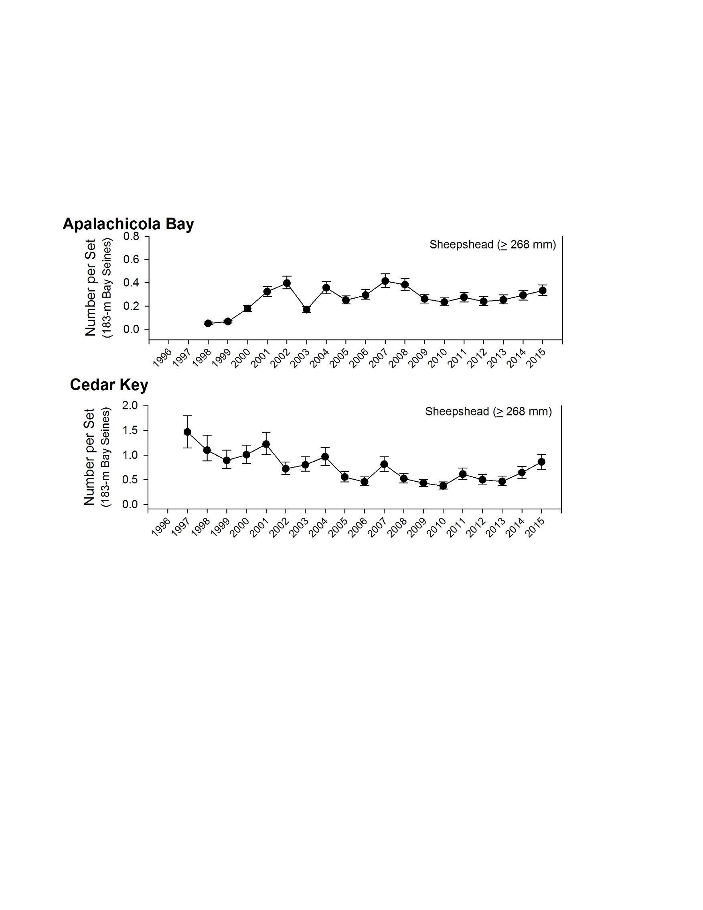

Figure SP15-01. Relative abundance of fully-recruited Sheepshead (> 268 mm SL) collected in 183-m haul seines between 1997 and 2015 during stratified-random sampling in the Apalachicola and Cedar Key estuarine systems. Points represent the median estimate while the vertical bars represent the 25th – 75th percentiles. Note different scales of abundance among plots for different gears and estuaries.

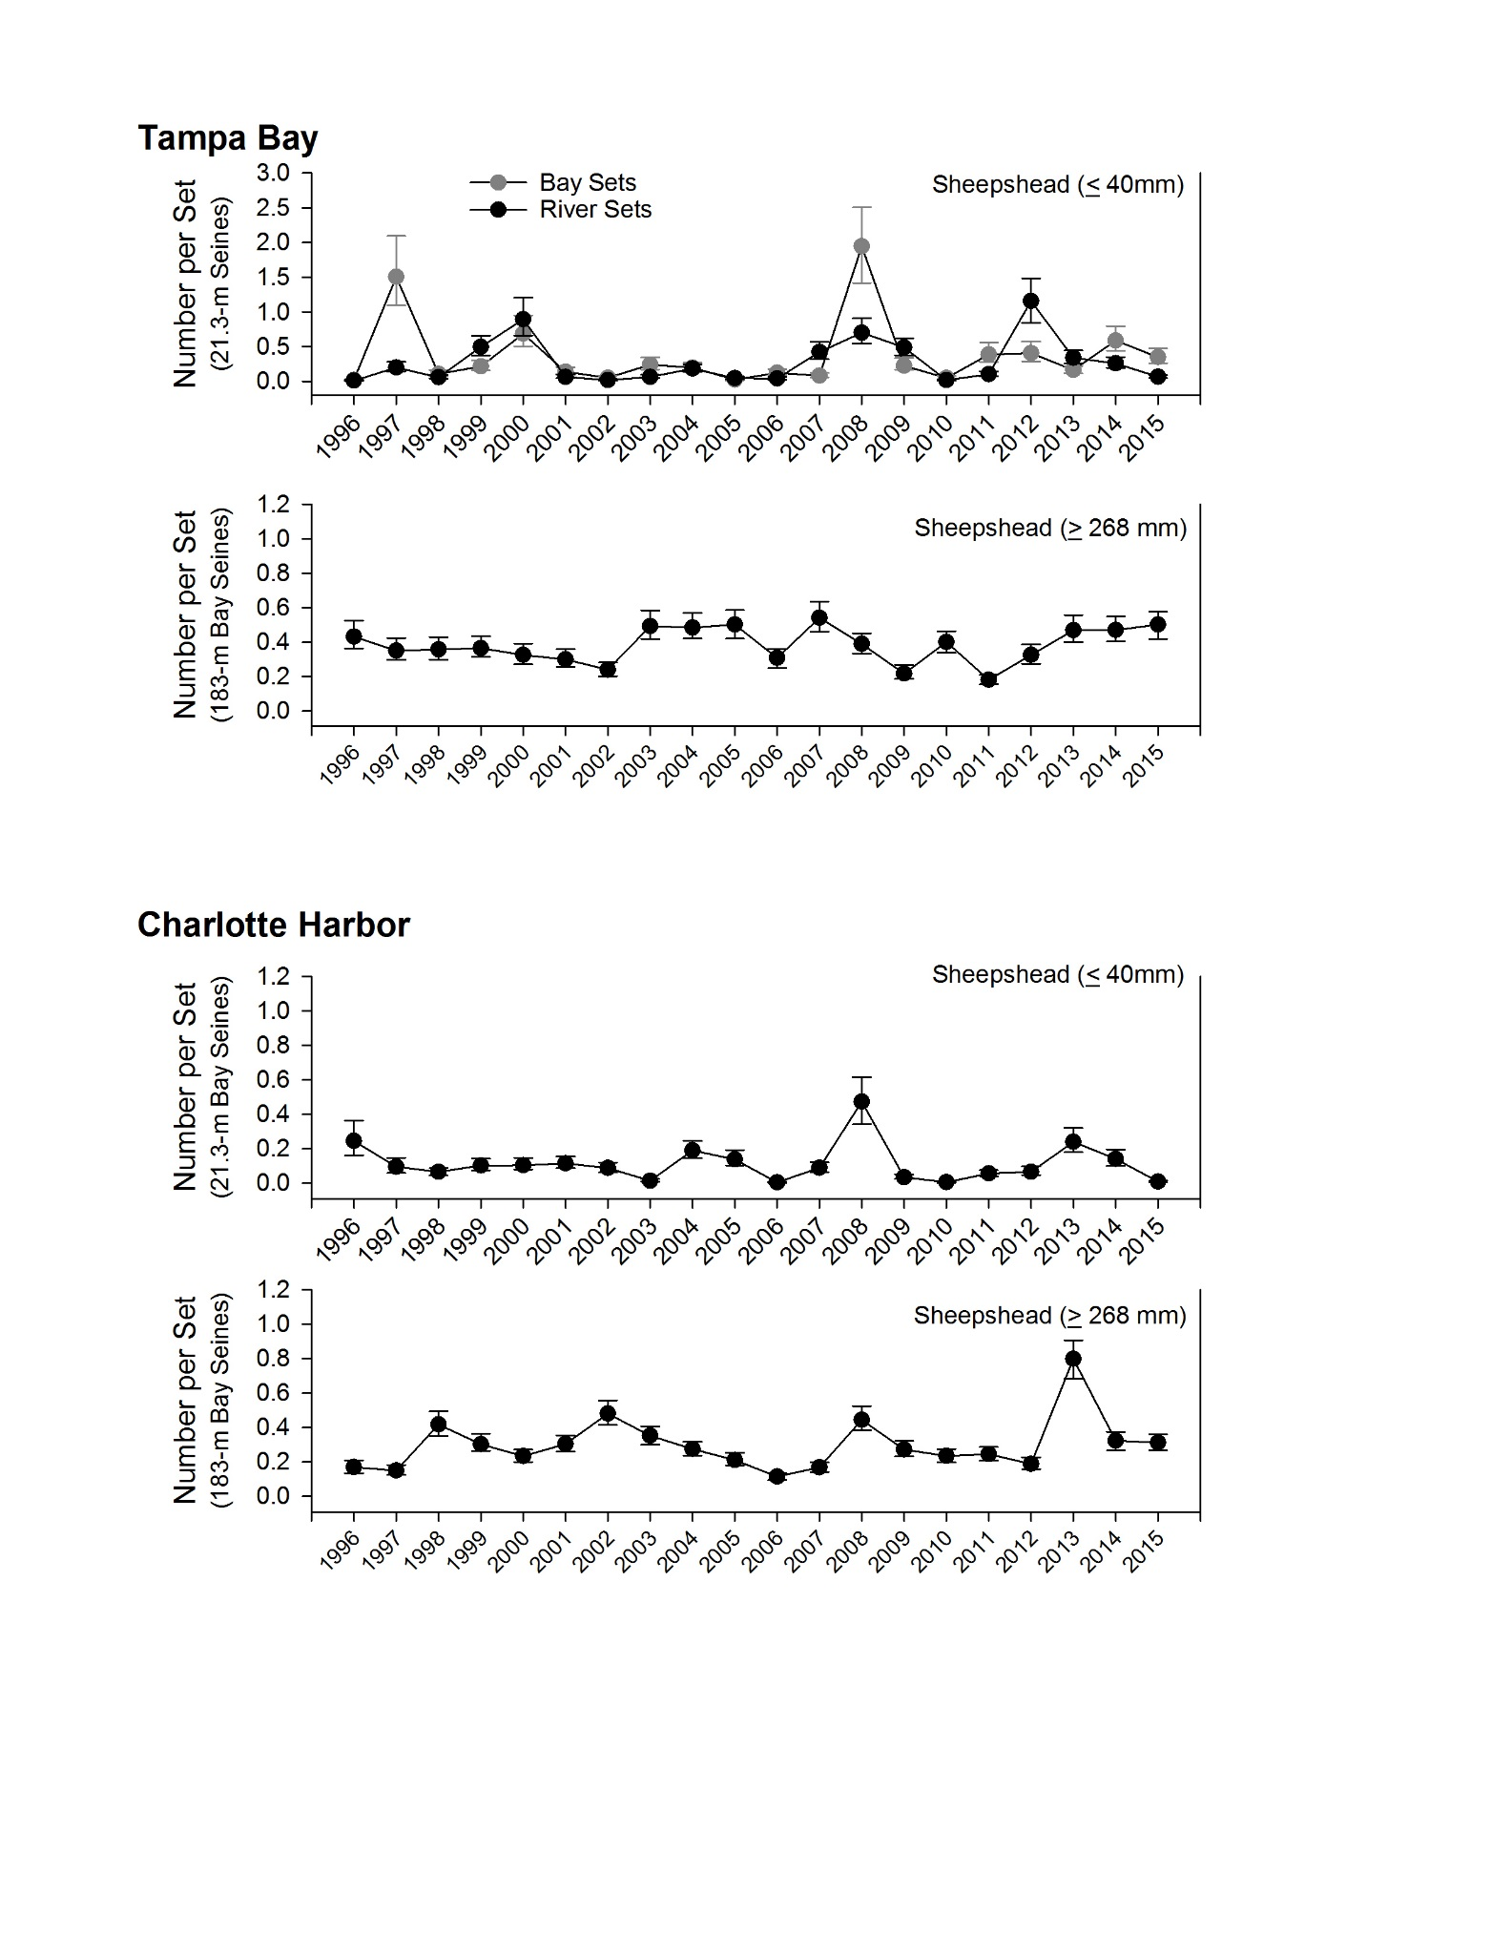

Figure SP15-02. Relative abundance of young-of-the-year Sheepshead (≤ 40 mm SL) collected in 21.3-m seines between 1996 and 2015 and fully-recruited Sheepshead (> 268 mm SL) collected in 183-m haul seines between 1996 and 2015 during stratified-random sampling from Tampa Bay and Charlotte Harbor estuarine systems. Points represent the median estimate while the vertical bars represent the 25th – 75th percentiles. Note different scales of abundance among plots for different gears and estuaries.

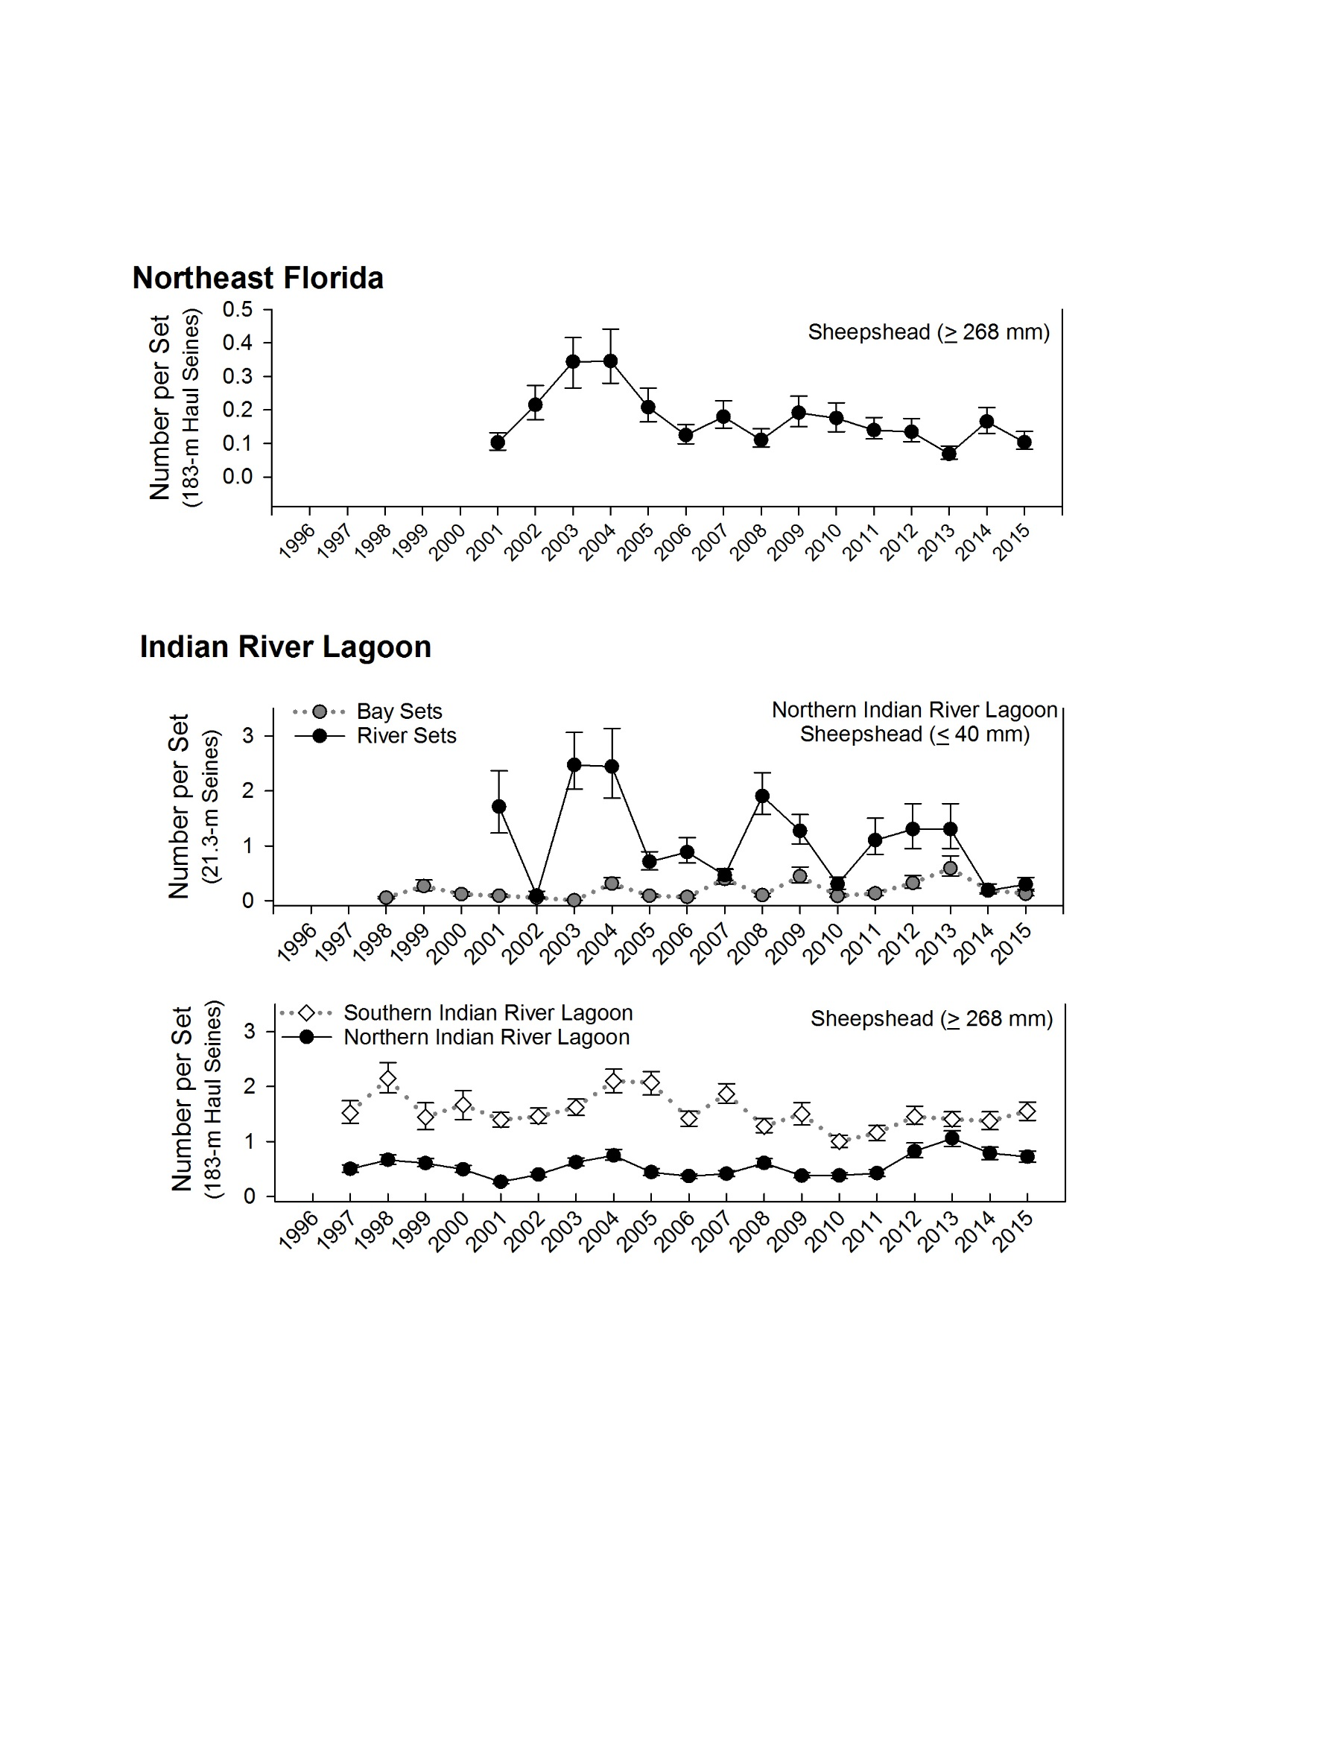

Figure SP15-03. Relative abundance of young-of-the-year Sheepshead (≤ 40 mm SL) collected in 21.3-m seines between 1998 and 2015 and fully-recruited Sheepshead (> 268 mm SL) collected in 183-m haul seines between 1997 and 2015 during stratified-random sampling from Northeast Florida, Northern and Southern Indian River Lagoon estuarine systems. Points represent the median estimate while the vertical bars represent the 25th – 75th percentiles. Note different scales of abundance among plots for different gears and estuaries.

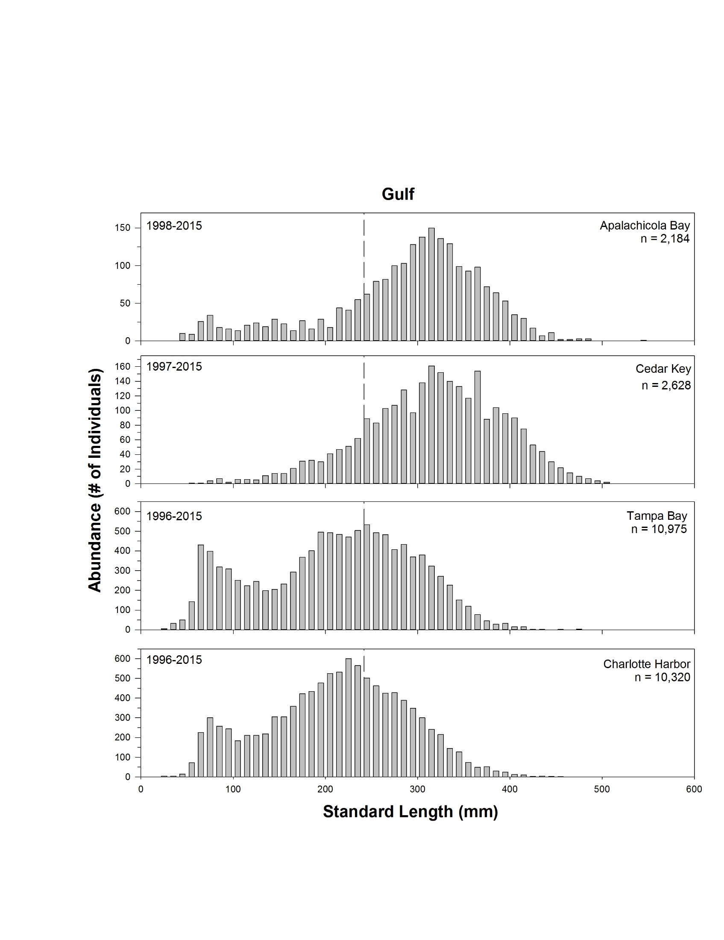

Figure SP15-04. Length frequency diagrams of Sheepshead collected in 183-m haul seines from Gulf coast Florida estuarine systems. Area after dashed line (- - -) indicates permitted recreational minimum harvest length (248 mm SL). All lengths are standard length (SL). Note different scales and years of collection among plots.

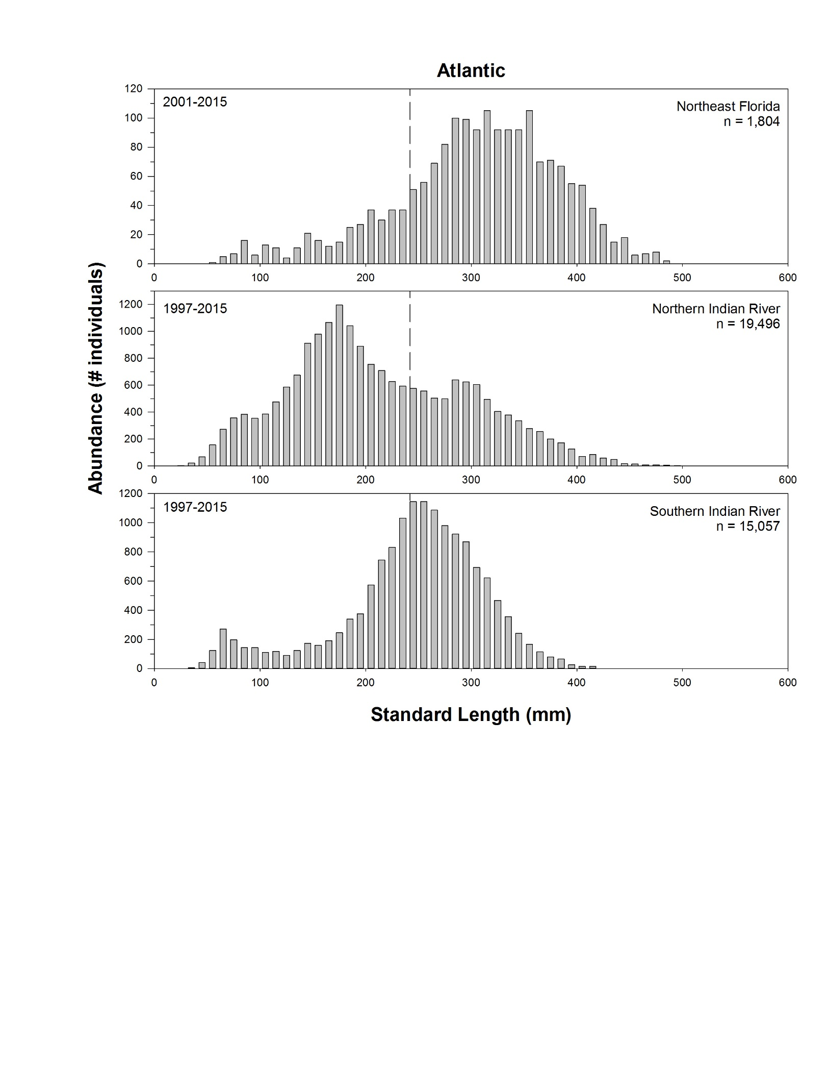

Figure SP15-05. Length frequency diagrams of Sheepshead collected in 183-m haul seines from Atlantic coast Florida estuarine systems. Area after dashed line (- - -) indicates permitted recreational minimum harvest length (242 mm SL). All lengths are standard length (SL). Note different scales and years of collection among plots.

Intentionally Left Blank